

**“BGP ROUTING CONFIGURATIONS”**  
LAB Project Nº 2

Report for “*Redes de Internet”* curricular unit

on the Bachelor Course of Informatics and Computer Engineering

**Group 3 authors:**

Diogo Bicho - nº41504

Tomás Pereira - nº49486

Margarida Pascoal - nº50929

**Professor:** Eng. Luís Mata

<< This page was intentionally left blank >>

# Index

Index 3

Figures List 4

Tables List 4

1. Introduction 5

2. Development 5

PHASE 1 – IGP CONFIGURATION 5

Practical Questions: 9

PHASE 2 - iBGP AND eBGP WITHOUT ROUTING POLICIES 14

Practical Questions: 16

PHASE 3 - ROUTING POLICIES IMPLEMENTATION 21

Practical Questions: 22

PHASE 4 - INFLUENCE THE INTERNET ROUTING 26

Practical Questions 29

PHASE 5 - SECURITY PRACTICES 31

Practical Questions 32

3. Conclusion 34

4. References 34

# Figures List

Figure 1 - Network topology 6

Figure 2 - OSPF neighbors with R12 7

Figure 3 - OSPF neighbors with R11 7

Figure 4 - OSPF neighbors with R10 8

Figure 5 - OSPF routes on R12 FIB 8

# 

# Tables List

Table 1 - Topology AS areas and Devices 6

Table 2 – eBGP neighbors configuration 15

# Introduction

This lab report document is focused on the implementation and validation of BGP protocol configurations.

Each phase includes objectives, implementation details, and validation evidence, developed on a GNS3 (Graphical Network Simulator-3) portable project file (.gns3project) which is appended to the comprehension of this report.

# Development

To achieve the requirements for this assignment we used the following environment:

• GNS3 (Graphical Network Simulator-3)

• Devices: Cisco switches/routers

• Connections: Ethernet interfaces between switches/routers

• Host Machines: PCs connected to specific switches for connectivity testing

## PHASE 1 – IGP CONFIGURATION

On the first stage of this work, we worked on configuring the Interior Gateway Protocol (IGP) the topology would be running on – in this case OSPF. An IGP is connected to Interior routers, i.e. devices living on the same Autonomous System (AS).

We started by setting up the interfaces as per the “Table 1 - IP addressing” provided on the essay requirements.

The topology consists of 8 AS’s and 16 routers. Each AS has some public IP addresses to be advertised to other AS’s via eBGP, configured on the next section of this work. Each router has also its router ID matching the address from its Loopback0.

The image below summarises the architecture of the project:

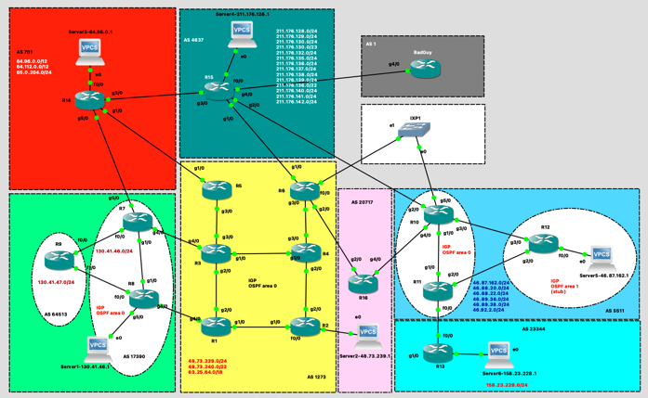

Figure 1 - Network topology

|  |  |  |
| --- | --- | --- |
| Color Area | AS | Device |
| Yellow | 1273 | R1, R2, R3, R4, R5, R6 |
| Green | 17390 | R7, R8, Server 1 |
| Green | 64513 | R9 |
| Blue | 5511 | R10, R11, R12, Server 5 |
| Cyan | 23344 | R13, Server 6 |
| Red | 701 | R14, Server 3 |
| Dark green | 4637 | R15, Server 4 |
| Pink | 20717 | R16, Server 2 |

Table 1 - Topology AS areas and Devices

To configure the IP addresses for all the interfaces of the 16 routers, we created a configuration file for each. We set up their hostname, the interfaces for their Loopback interfaces (0 and 1), the ones for each of their ports and the OSPF network settings.

As an example these were the following OSPF settings for Router 1:

*router ospf 1*

*log-adjacency-changes*

*router-id 10.1.1.1*

*passive-interface Loopback0*

*passive-interface Loopback1*

*network 10.1.1.1 0.0.0.0 area 0*

*network 10.1.2.0 0.0.0.3 area 0*

*network 10.1.3.0 0.0.0.3 area 0*

All routers had only one OSPF area (Backbone Area 0) except for AS 5511 (routers 10,11,12), which needed the backbone (Area 0) and one stub area (Area 1).

On AS 5511, Router 10 and 11 were Area Border Routers and Router 12 was on Area 1. Therefore, all links to R12 were on Area 1 and the rest on Area 0.

Verified OSPF neighbors successfully on R10, R11 and R12:

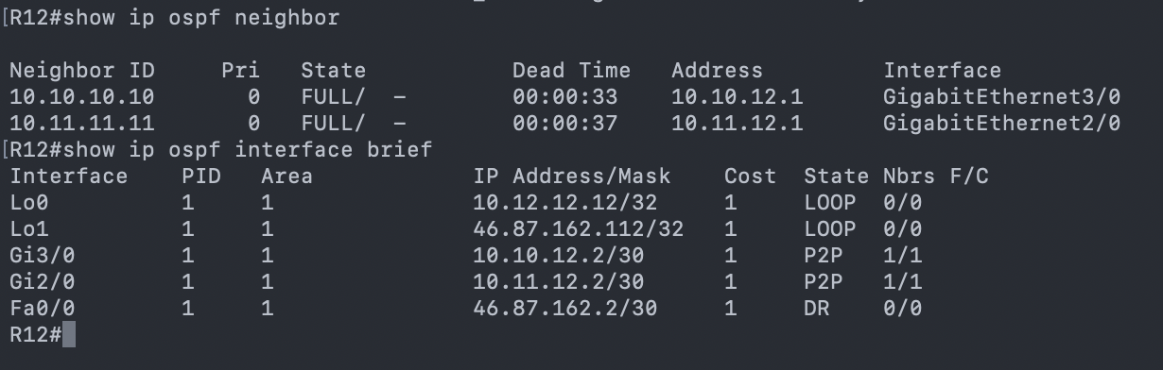

Figure 2 - OSPF neighbors with R12

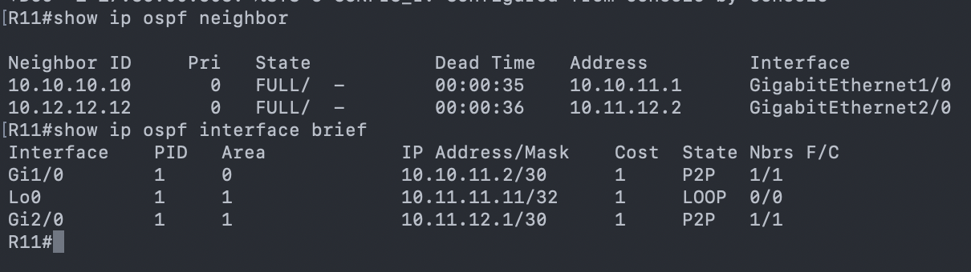

Figure 3 - OSPF neighbors with R11

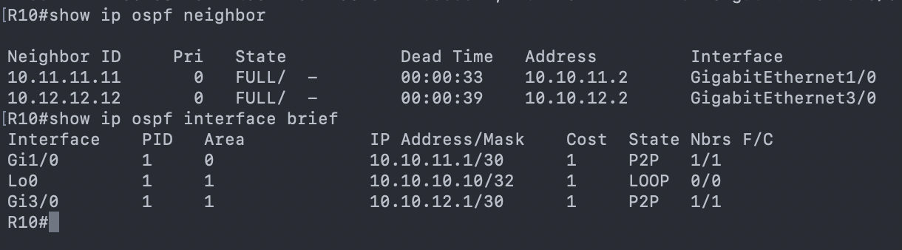

Figure 4 - OSPF neighbors with R10

On R10 we confirmed the R11 and R12 were registered OSPF neighbours. Only the internal link to R11 was in Area 0, the Loopback and the link to R12 were both in Area 1. On R11 we checked the same behaviour, with R10 and R12 as neighbours and on R12 all links were on Area 1 as required.

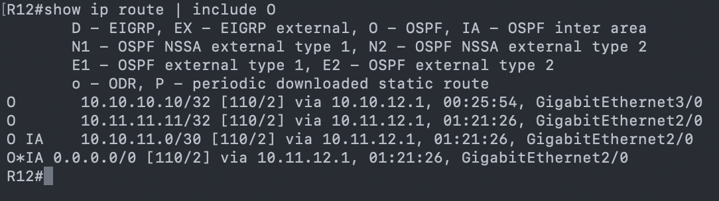

Figure 5 - OSPF routes on R12 FIB

Using the command “show ip route” on R12 (which is located in Area 1), we can see all the routes learned through OSPF.  
Routes marked with “O” are intra-area routes, meaning they were learned from within the same OSPF area (Area 1). In this case, these include the loopback networks of R10 and R11, which are advertised into Area 1.

Routes marked with “O IA” are inter-area routes, meaning they were learned from a different OSPF area. For example, the entry: “O IA 10.10.11.0/30 via 10.11.12.1” shows that R12 is learning the network 10.10.11.0/30 (which belongs to Area 0) through the ABR R11, via its link 10.11.12.1.

Because Area 1 is configured as a stub area, R12 also receives a default route (0.0.0.0/0) generated by the ABR. This forces all traffic from Area 1 that does not match a more specific prefix to be forwarded toward Area 0 (the backbone).

##### Practical Questions:

1. **Create a comprehensive table presenting all the connectivity tests carried out and the respective outcome (*e.g.,* success, failure). You don’t need to provide exhaustive snapshots for all test results. Choose only three example cases, from different ASes, to include in your report and briefly comment on each selected case.**

|  |  |  |  |  |
| --- | --- | --- | --- | --- |
| Test | Source | Destination | Path | Result |
| ping | R7 (AS 17390) | R8 (AS 17390) | AS 17390 | Success |
| ping | R8 (AS 17390) | R1 (AS 1273) | Via eBGP only | Failed |
| ping | R1 (AS 1273) | R2 (AS 1273) | AS 1273 | Success |
| ping | R6 (AS 1273) | R1 (AS 1273) | AS 1273 | Success |
| ping | R12 (AS 5511) | Server5 (AS 5511) | AS 5511 | Success |
|  |  |  |  |  |

Table 2 - Ping tests for phase 1

1. **Use the hops://bgp.tools/ to identify the ASes entities involved in the lab topology.**

|  |  |  |
| --- | --- | --- |
| AS | Area color | Entities |
| 17390 | Green | IBM |
| 64513 | Green | Private ASN |
| 701 | Red | Verison Business |
| 4637 | Dark Green | Telstra Global |
| 5511 | Blue | Orange S.A. |
| 20717 | Pink | DE-CIX Marseille Route Servers |
| 23344 | Light Blue | Disney Worldwide Services, Inc. |
| 1 | Grey | Level 3 Parent, LLC |
| 1273 | Yellow | Vodafone Group PLC |

Table 3 - AS entities association on Phase 1

1. **Explain the concept of an Autonomous System (AS) in the Internet architecture and provide examples associated with the Portuguese Internet ecosystem.**

An Autonomous System (AS) contains routers under a single administrative domain, i.e., it is a set of routers and IP networks managed by a single entity. Normally each AS is assigned a globally unique 16-bit or 32-bit AS number (ASN) which is registered by IANA (Internet Assigned Numbers Authority) and distributed by Regional Internet Registries (RIRs).

All routers within an AS typically run the same Interior Gateway Protocol (IGP) (e.g., OSPF, IS-IS, EIGRP) to exchange routing information within a domain. The communication between different AS’s is done thanks to EBGP.

Considering the context of EBGP, there are different types of AS: **Providers**, which give upstream connectivity to **Customers** and **Peers** which normally occurs to exchange routing information without financial compensation, normally between ISPs or an ISP and a customer.

Examples in the Portuguese Internet ecosystem would be: AS3243 – MEO / Altice Portugal, AS12353 – Vodafone Portugal, AS15525 – Claranet Portugal, AS9186 – ONI Telecom, AS20940 – Claranet

1. **Classify each AS in the lab project as Tier-1 or Tier-2. For each classification, describe the evidence you find in the lab topology that justifies it.**

|  |  |  |  |
| --- | --- | --- | --- |
| AS | Area color | Entities | Tier |
| 17390 | Green | IBM | 2 |
| 64513 | Green | Private ASN | 2 |
| 701 | Red | Verison Business | 1 |
| 4637 | Dark green | Telstra Global | 1 |
| 5511 | Blue | Orange S.A. | 1 |
| 20717 | Pink | DE-CIX Marseille Route Servers | 2 (Transit) |
| 23344 | Blue cyan | Disney Worldwide Services, Inc. | 2 |
| 1 | Grey | Level 3 Parent, LLC | 2 |
| 1273 | Yellow | Vodafone Group PLC | 1 |

Table 4 - AS associations per tier

1. **Create a table showcasing all the peering relations established in the provided topology.**

|  |  |  |  |  |  |
| --- | --- | --- | --- | --- | --- |
| **Local Router** | **Local AS** | **Neighbor Router** | **Neighbor AS** | **Peering Type** | **Interface** |
| R14 | AS701 | R5 | AS1273 | eBGP | g1/0-g1/0 |
| R14 | AS701 | R7 | AS17390 | eBGP | g5/0-g5/0 |
| R14 | AS701 | R15 | AS4637 | eBGP | g3/0-g3/0 |
| R7 | AS17390 | R3 | AS1273 | eBGP | g4/0-g4/0 |
| R7 | AS17390 | R8 | AS17390 | iBGP | g1/0-g1/0 |
| R7 | AS17390 | R9 | AS17390 | iBGP | f0/0-f0/0 |
| R8 | AS17390 | R9 | AS17390 | iBGP | f0/0-f1/0 |
| R8 | AS17390 | R1 | AS1273 | eBGP | g4/0-g4/0 |
| R5 | AS1273 | R3 | AS1273 | iBGP | g3/0-g3/0 |
| R3 | AS1273 | R4 | AS1273 | iBGP | g1/0-g1/0 |
| R3 | AS1273 | R1 | AS1273 | iBGP | g2/0-g2/0 |
| R1 | AS1273 | R2 | AS1273 | iBGP | g1/0-g1/0 |
| R2 | AS1273 | R4 | AS1273 | iBGP | g2/0-g2/0 |
| R4 | AS1273 | R6 | AS1273 | iBGP | g3/0-g3/0 |
| R6 | AS1273 | R16 | AS20717 | eBGP | g2/0-g2/0 |
| R6 | AS1273 | R15 | AS4637 | eBGP | g1/0-g1/0 |
| R16 | AS20717 | R10 | AS5511 | eBGP | g4/0-g4/0 |
| R10 | AS5511 | R15 | AS4637 | eBGP | g2/0-g2/0 |
| R10 | AS5511 | R11 | AS5511 | iBGP | g4/0-g1/0 |
| R10 | AS5511 | R12 | AS5511 | iBGP | g3/0-g3/0 |
| R11 | AS5511 | R13 | AS23344 | eBGP | f0/0-f0/0 |
| R11 | AS5511 | R12 | AS5511 | iBGP | g2/0-g2/0 |
| R15 | AS4637 | BadGuy | AS1 | eBGP | f0/0-g4/0 |
| IXP1 | - | R6 | AS1273 | eBGP | e1-f0/0 |
| IXP1 | - | R10 | AS5511 | eBGP | e0-g5/0 |

Table 5 - Peering relations on phase 1

1. **Explain how a Tier-2 benefits from peering instead of buying everything from a Tier-1.**

Tier-2 networks:

* Reduce transit costs (sending traffic via Tier-1 is expensive)
* Improve latency (shorter paths via peering)
* Increase redundancy (multiple peer paths)
* Improve performance for local/regional users

1. **Identify the neutral public peering interconnections in this lab topology. Elaborate on why they are called neutral and provide examples of real-world implementations of such public interconnections.**

In the lab topology, neutral public peering interconnections are represented by the shared IP segments where multiple autonomous systems connect, such as the 48.73.240.x (link between R1 and R8, R2 and R7, R15 and R6, etc), 64.112.0.x (R14 links to other ASs) and 211.176.129.x networks (R15 to R10 for example). These networks simulate public Internet Exchange Points (IXPs), which are neutral Ethernet fabrics that allow multiple ISPs to establish BGP peering sessions. They are called “neutral” because the exchange is not owned or controlled by any single ISP. In summary, it’s the network fabric where different autonomous systems (ASes) interconnect via a common shared network.

1. **Explain the role of R12 in AS 5511, and how are its interfaces divided between the OSPF areas involved.**

R12 is an ABR connecting Area 0 (backbone) to Area 1 (stub). Interfaces to Area 0 are: R10 link, R11 (both backbone routers) and Loopback0. Area 1 interface is the 46.87.162.0/24 subnet. The purpose of an ABR is to separate backbone from a stub area, advertising a route into Area 0.

An ABR connects routers from multiple areas (including the backbone), and its responsible to exchange routing information.

1. **Explain what a stub area is and discuss the resulting advantages and potential limitations. In your discussion, please detail under what conditions would multi-area OSPF be preferred over a single backbone area in real networks.**

A stub area is a special type of OSPF area created to reduce the amount of routing information a router must process and store. In a stub area Type 5 LSAs (External routes) are not allowed, instead the ABR (Area Border Router) injects a default route into the area. This is common in small or remote branches because it minimizes the LSDB size and CPU load on routers with limited resources.

Advantages:

* Reduces routing table size- Since no external routes enter the area, routers rely on a single default route for outside destinations.
* Less LSA flooding- No Type 5 LSAs, lower link-state overhead, faster convergence inside the area.
* Lower CPU and memory usage- The LSDB is smaller, and SPF recalculations are simpler.

Limitations:

* No external routes are allowed- If visibility of external prefixes inside the area is needed, a stub area will not work.
* Cannot contain an ASBR- A stub area cannot host a router that redistributes external routes, because that would violate the “no Type 5 LSAs” rule.
* All routers must agree- Every router in the area must be configured as a stub.
* Single-exit expectation- Stub areas work best when there is ONE ABR providing a clean default route. If a stub area has multiple exit points, routing may be sub-optimal.

When multi-Area OSPF is preferred:

Scalability Limits - Large flat (single-area) topologies can cause, Large LSDBs, High CPU use on routers and longer convergence times, Multi-area OSPF reduces these by dividing the network and SPF domains.

* + Geographic Distribution- If the network spans over many remote sites, regions, or countries, dividing them into areas:
    - localizes link failures
    - reduces LSA flooding
    - isolates topology changes to smaller regions.
  + Security and Administrative Separation- Different departments, customers, or service types can be isolated logically.
  + Optimizing Routing for Branch Offices- Branch or remote sites often benefit from:
    - Stub areas (simple connectivity via default route)
    - NSSA areas (when redistribution is needed near the edge)

Limiting the impact of instability- A flapping link in one area does not cause SPF recalculation in all areas, only inside that area.

1. **Discuss why the subnet 46.87.162.0/24 was not placed on the backbone area, considering the OSPF design principles.**   
     
   That subnet was allocated to server 5 (an end user) and the OSPF principles state that Access/edge or end-user networks should be in non-backbone areas.

## PHASE 2 - iBGP AND eBGP WITHOUT ROUTING POLICIES

Border Gateway Protocol (BGP) is a routing protocol to exchange information between different networks. In this case BGP manages communication between the different Autonomous Systems.

On this stage, we configured BGP process for each AS and on the case of external links we established appropriate eBGP sessions. On every AS and belonging router we started by registering the static routes with the prefixes to be announced via BGP. We then configured the BGP session to have the ID of the belonging AS and the router ID in question to match the Lo0 interface of said router. Its neighbours were defined identifying the AS to which they belong to and finally the network to be announced via BGP. Next, we present an example of the commands ran for R1:

*enable*

*conf t*

*! static routes*

*ip route 130.41.47.0 255.255.255.0 Null0*

*! BGP configuration*

*router bgp 64513*

*bgp router-id 10.9.9.9*

*no synchronization*

*bgp log-neighbor-changes*

*neighbor 130.41.46.9 remote-as 17390*

*neighbor 130.41.46.9 soft-reconfiguration inbound*

*neighbor 130.41.46.5 remote-as 17390*

*neighbor 130.41.46.5 soft-reconfiguration inbound*

*network 130.41.47.0 mask 255.255.255.0*

*no auto-summary*

*end*

*wr*

This protocol has two variants, iBGP for the links within the same AS and eBGP for the links connecting different AS’s. For AS 1273, and to avoid a full mesh type configuration, we needed to configure 2 route reflectors on R3 and R4 in order to forward external routes to the rest of the routers of the AS (R1, R2, R5 and R6 registered as clients).

Server subnet public IPs were listed in the internet routing table and were announced with the “network” command, together with Lo1 to allow reachability from any server.

|  |  |  |  |
| --- | --- | --- | --- |
| Area AS | Color | Neighbors AS | Neighbor’s Color |
| 701 | Red | 1273 | Yellow |
| 4637 | Dark green |
| 17390 | Light Green |
| 1273 | Yellow | 701 | Red |
| 4637 | Dark green |
| 17390 | Light green |
| 20717 | Pink |
| 4637 | Dark green | 701 | Red |
| 1273 | Yellow |
| 5511 | Blue |
| 1730 | Light green | 1273 | Yellow |
| 701 | Red |
| 20717 | Pink | 1273 | Yellow |
| 5511 | Blue |
| 23344 | Cyan | 5511 | Blue |
| 1 | Grey | 4637 | Dark green |

Table 6 – eBGP neighbors configuration

Testing and validation involved running the following commands:

*show ip bgp*

*show ip bgp summary*

*show ip route bgp*

*show ip bgp neighbors 10.6.6.6 received-routes*

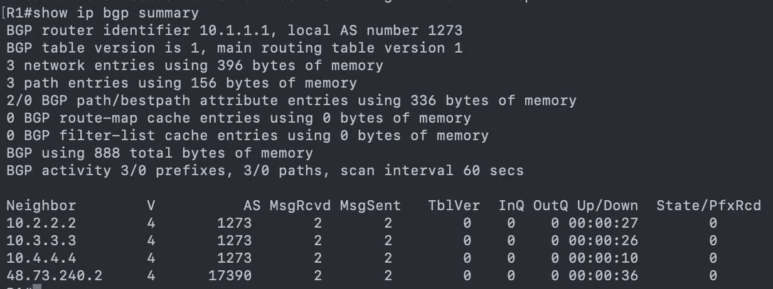

Figure 6 - Example of output of show ip bgp summary ran for R1

##### Practical Questions:

1. **How is the BGP next hop reachability solved inside an AS?**

Inside an AS, BGP next-hop reachability is provided by the IGP (OSPF, per example).

BGP does not discover next hops on its own, when a router receives a BGP route, it installs it only if the NEXT_HOP address is reachable in the routing table via the IGP.

Bgp relies entirely on the IGP to make the BGP next-hop reachable, internal routers must have an IGP route to the next-hop IP, or the BGP route will be rejected.

1. **Why is it a good practice to use the loopback IP address in the iBGP sessions?**

Using a loopback IP address for iBGP sessions is considered best practice because it makes the BGP session stable, reliable, and independent of physical interfaces.

Stability- Loopbacks never go down unless the router goes down.

Redundancy and Resilience- If you use a physical interface for BGP, the session depends on that specific link. With a loopback, any path in the IGP can be used to reach the loopback, If one links fails, traffic reroutes through another path, the BGP session survives internal failures.

Simpler network design- Loopbacks provide a stable, unique identifier for the router.

1. **Create and present a detailed table with all the connectivity tests performed using the TCLSH procedure, as previously outlined.**

We ran the provided tclsh script at the end of the report on R9 router and we got the following output, with 100% success in all attempts of ping.

Figure 7 - tclsh command ran for R9 according to requirement

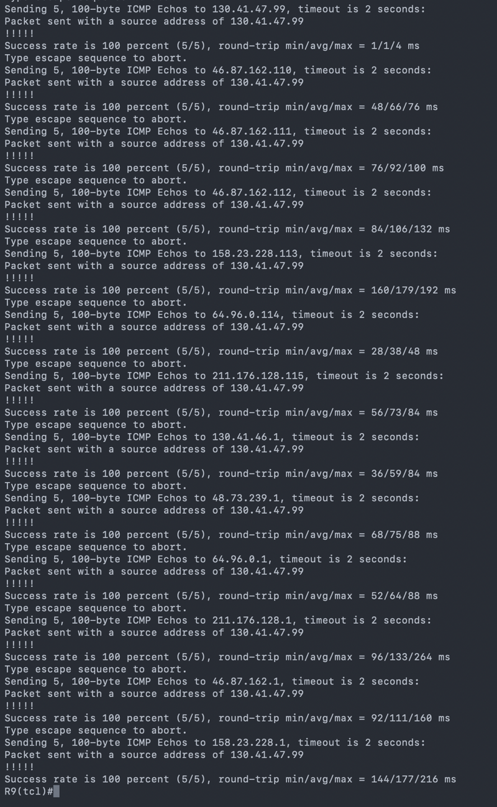

Figure 8 - tclsh command ran for R9 (part 2)

1. **In the following Local-RIB table output example, how many routes were installed for the destination 46.87.162.0/24? Justify your response explaining the decision process in BGP.**  
   **|**

One route was installed (the one marked with > as the best route). Even if multiple BGP routes are received for 46.87.162.0/24, BGP selects only a single best path using its decision algorithm (local-pref, AS-path, origin, MED, eBGP > iBGP, IGP metric). Only this best path is installed in the Loc-RIB. Therefore, only one route appears in the routing table for 46.87.162.0/24.

1. **What would have happened in case you didn’t configure the next-hop-self on the iBGP peering definitions? What reasons explain why BGP doesn’t set the next-hop-self as a default setting?**

If you do not configure next-hop-self on an iBGP router that receives routes from an eBGP peer: By default, when a router redistributes a route from eBGP to iBGP, the next hop is not changed. So the next hop remains the external router’s IP.

If the internal routers do not have an IGP route to that external next-hop address, the route will be rejected because “next-hop is not reachable”, will lose connectivity to the advertised prefix and have incomplete routing table. This caused blackholes or missing routes inside the AS.

BGP doesn’t use next-hop-self by default, because it is designed to preserve accurate routing and policy. The original design philosophy of BGP is: “Do not modify attributes unless explicitly configured by the operator.”

The external next hop carries important information, such as proximity to the destination, exit point selection and routing policies. Automatically overwriting the next hop would hide this information and reduce routing control.

1. **How are the route prefixes propagated inside the AS when you have route reflectors configured?**

With route reflectors, route prefixes propagate through the RR, which reflects iBGP-learned routes between its clients and peers, eliminating the need for a full iBGP mesh inside the AS.

1. **Simulate and explain using Wireshark the BGP messages associated to each BGP state (see: hops://www.ciscopress.com/articles/article.asp?p=2756480&seqNum=4).**

_______

#### 

## PHASE 3 - ROUTING POLICIES IMPLEMENTATION

The primary objectives for this phase were to ensure efficient route aggregation, enforce global routing table standards (preventing prefixes longer than /24), secure peering sessions by limiting prefix counts to 50, make private AS announcements limited and have AS 23344 with a single default peering eBGP route.

To reduce the size of the routing table and improve stability, we utilized the “aggregate-address” command with the “summary-only” keyword. This ensures that while we may have multiple specific subnets in our internal table, only the single, summarized block is advertised to external peers.

*router bgp 1273*

*aggregate-address 211.176.128.0 255.255.254.0 summary-only*

For the second objective, we were required to filter out prefixes longer than /24 (e.g., /25, /30) to prevent table exhaustion over smaller networks. We implemented an IP Prefix List to match any route with a subnet mask length up to /24. The implicit deny at the end of the list blocks any prefix longer than /24.

We used the following command:

*ip prefix-list PREF_LIST_ADV_SUMM seq 5 permit 0.0.0.0/0 le 24*

*neighbor 211.176.129.1 prefix-list PREF_LIST_ADV_SUMM out*

In summary, it defines a prefix list named “PREF_LIST_ADV_SUMM” with a sequence number of 5 of type “permit” which allows all prefixes lower or equal to /24. Afterwards it applies said prefix list to the outward announcements of a registered neighbor to that router in question.

We have applied this command to all eBGP connections of all routers of the topology.

Regarding the third objective, we limited the acceptance of neighbour's prefixes announcements to the maximum of 50 prefixes, this was easily achieved by running:

*neighbor 48.73.240.2 maximum-prefix 50*

To accomplish the private AS management objective we considered AS 64513 as the only private AS of the topology. Its neighbour is AS 17390 which had R7 and R8 and on each one of them we configured the peer with the private AS to not show on the AS PATH when advertising updates to external peers. Private AS’s should not be leaked to the public internet.

*neighbor 130.41.46.10 remove-private-as*

The final objective was to address AS 23344, as it only has one router (R13) and one single neighbour (AS 5511 via a single point of entry R11) we wanted to configure a default unique route to be announced to it from R11:

*ip prefix-list ONLY_DEFAULT seq 5 permit 0.0.0.0/0*

*neighbor 46.88.20.6 prefix-list ONLY_DEFAULT out*

##### 

##### Practical Questions:

1. After applying your prefix-list or route-map, compare the output of show ip bgp and show ip bgp neighbors <ip> advertised-routes. Explain the differences you observe referring to the **Adj- RIB-In, Adj-RIB-Out, and Loc-RIB** tables.

To verify the route aggregation and filtering policies, we compared the Local Routing Information Table (Loc-RIB) against the Adjacency RIB-Out (Adj-RIB-Out) on Router R15. The comparison highlights how BGP processes local knowledge versus what it advertises to peers.

The command show ip bgp displays the Loc-RIB. This table contains every valid route the router is aware of, regardless of whether it will be advertised to neighbors.

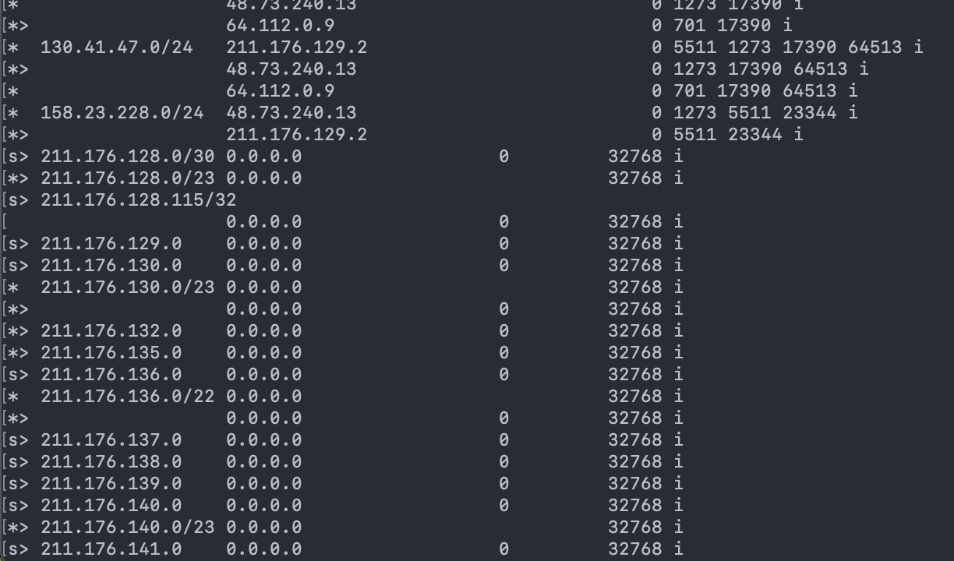In the output for R15, we observe the specific subnets that exist, such as the Loopback1 211.176.128.115/32. However, these specific routes are marked with the status code s (suppressed) provided by the aggregate-address commands we used to aggregate the network announcements.

Figure 9 - Suspended routes example on R15

The command *show ip bgp neighbors 48.73.240.13* advertised-routes displays the **Adj-RIB-Out**. This table represents the routes sent to the neighbor (R6).

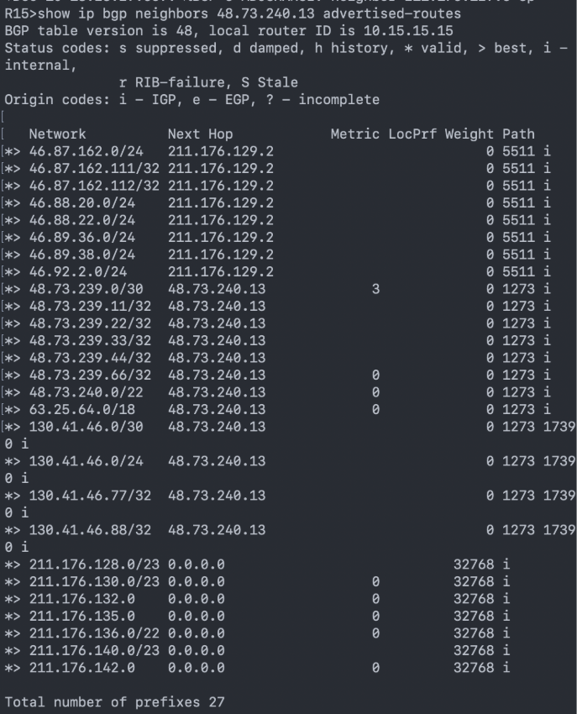

Figure 10 - Advertised prefixes to neighbors on R15

2. Why is the control from the number of prefixes advertised to the internet a good practice?

Controlling the number of advertised prefixes is essential because:

* Prevents routing table pollution  
   Advertising too many small prefixes (/25+/30/etc.) increases the global routing table size and harms scalability.
* Protects your upstream peers  
   Upstream providers commonly expect aggregated prefixes.
* Avoids accidental route leaks  
   Misconfiguration may leak internal or customer routes to the Internet.  
   A maximum-prefix limit stops the session before damage happens.
* Stability and convergence  
   Fewer prefixes means faster BGP convergence and fewer CPU cycles.

So limiting outbound prefixes is a standard ISP best practice.

3. What is the **private AS number range** in BGP? Describe some scenarios where using private ASNs can be useful.

The official private ASN ranges are: [4]

* **16-bit ASNs:** 64512–65534
* **32-bit ASNs:** 4200000000–4294967294

Common use cases:

* **Customer edge routers that connect to a single ISP**  
   The ISP does not want customer ASNs visible on the global Internet.
* **Internal BGP confederations**  
   Large ISPs use private ASNs for internal sub-ASes.
* **Lab environments or academic networks**  
   Where public ASN registration is not necessary.

Private ASNs must be **removed** before routes are announced publicly.

4. Assume that you successfully configured prefix filtering. Based on the **BGP path selection rules**, explain why R12 selects a specific path for the prefix 65.0.204.0/24. Use the following output as reference (hop://www.cisco.com/en/US/tech/tk365/technologies_tech_note09186a0080094431.shtml):

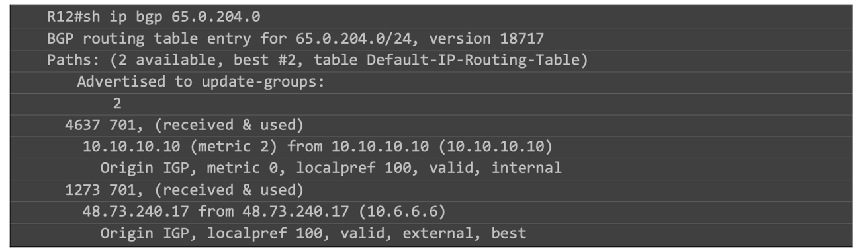

Figure 11 - Example provided for questions on Phase 3

The rule is that eBGP-learned routes are preferred over iBGP-learned routes. In this example, as they both have the same localpref value (100), same AS path length, the main difference is that one is external and the other internal. It gives precedence to the route learned via R6 (from an external AS).

5. Imagine that one of your prefixes was not selected as the best path in your lab. Based on the **BGP decision process**, propose a configuration change (e.g., adjusting local preference, MED, or weight) that would alter the selection. Justify your answer by showing the relevant command(s) and predicting the impact on the routing table.

To influence a path to be chosen via BGP the attributes needed to be adjusted with the following logic:

* **Weight**: needs to be increased (highest wins). It works as a local override to manually preferred paths.

Example on R12:

*router bgp 5511*

*neighbor 10.10.10.10 weight 500*

*End*  
  
Traffic originating from R12 would now follow next-hop toward R10.

* **Local Preference** (highest wins). This influences the entire AS preference for outbound routing.
* **AS Path** (shorter wins)

* **MED** (lowest wins) Influences inbound traffic on the local AS

## PHASE 4 - INFLUENCE THE INTERNET ROUTING

The main objective of this phase is to control how traffic flows between Autonomous Systems by manipulating BGP attributes. Unlike previous phases, where routing decisions were determined naturally by IGP metrics or default BGP behaviour, this stage focuses on actively shaping the internet routing path to ensure predictable, stable, and symmetric traffic.

To achieve this, we define polices that influences the BGP decision process both inbound (how our AS selects external routes) and outbound (how other ASes select the routes we advertise). This is done using mechanisms such as local preference, AS-path prepending, prefix-lists, and route-maps. By applying these policies consistently along the entire path, we ensure that AS20717 becomes the preferred transit AS in both directions, creating coherent and predictable routing behaviour across the internet topology.

The selected BGP attributes (Local Preference, AS-Path Prepending, prefix-list and route-maps) were chosen because they are the standard and most effective mechanisms used in real ISP environments to influence routing decisions without breaking BGP fundamental behaviour.

Example:

*ip prefix-list FROM_AS20717 seq 5 permit 0.0.0.0/0 le 32*

*route-map RM_PREF_AS20717_IN permit 10*

*match ip address prefix-list FROM_AS20717*

*set local-preference 200*

*router bgp 1273*

*neigneighbor 48.73.240.22 route-map RM_PREF_AS20717_IN in*

*neighbor 48.73.240.17 send-community both*

To confirm the configuration was right we used *show ip bgp* to ensure that routes through AS20717 are marked as the best.

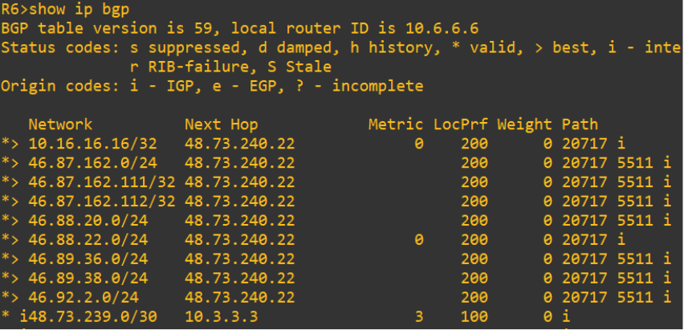

Figure 22 – R6 LocPrf 200

The field LocPrf shows that the route through AS20717 is marked as the best since as a higher preference that the other paths, then Using show ip bgp | include 20717 we can filter just the path that include the AS20717

Uma imagem com texto, captura de ecrã, menu

Os conteúdos gerados por IA podem estar incorretos.

Figure 23 – R6 BGP ips filtered to AS20717

Using show ip bgp neighbours 48.73.240.22 advertised-routes we see what R6 advertise to R16

Uma imagem com texto, captura de ecrã, menu, Tipo de letra

Os conteúdos gerados por IA podem estar incorretos.

Figure 24 – R6 advertised-routes to R16

Finaly to make sure that the chosen path is the one we want we run traceroute 46.88.20.1 which one of the ips of R10 we see that it has 2 hops the first one belongs to R16 and the last one is the ip we wanted which belongs to AS5511 where R10 is situated.

Uma imagem com texto, captura de ecrã, Tipo de letra

Os conteúdos gerados por IA podem estar incorretos.

Figure 25 – R6 route to R10

##### Practical Questions

**1. Describe in your report the policy options you used to implement the routing policies (include all the details of the configurations (e.g., prefix-list, route-map, etc).**

In order to enforce the required BGP routing policies between AS1273, AS20717 and AS5511, a set of policy-control mechanisms was deployed using prefix-lists, route-maps, and neighbor-specific inbound policy application.

Prefix-lists- were used to match the routes received from specific external ASes, allowing the router to classify which should receive modified BGP attributes.

Defined on R6 and R10:

ip prefix-list FROM_AS20717 seq 5 permit 0.0.0.0/0 le 32

This prefix-list matches all routes learned from AS20717, enabling us to apply policy to all its prefixes. This ensures every prefix from AS20717 is eligible for the inbound policy.

Route-Maps- was implemented to modify the LOCAL_PREFERENCE attribute for a specific neighbor.

Defined on R6 and R10:

*route-map RM_PREF_AS20717_IN permit 10*

*match ip address prefix-list FROM_AS20717*

*set local-preference 200*

This increase LOCAL_PREF for routes coming from AS20717 to 200 which is higher than the default (100), this makes AS20717 the preferred inbound path within AS1273 and AS5511.

The route-map is applied inbound on the EBGP session with AS20717.

On R6:

*neighbor 48.73.240.22 route-map RM_PREF_AS20717_IN in*

On R10:

*neighbor 46.88.20.2 route-map RM_PREF_AS20717_IN in*

This makes all routes learned from AS20717 enter BGP table with LOCAL_PREF = 200, making these routes preferred over those learned from AS4637

**2.** **Provide command output screenshots that demonstrate the successful application of the configured policies.**

Uma imagem com texto, captura de ecrã, Tipo de letra

Os conteúdos gerados por IA podem estar incorretos.

Figure 26 – R10 route to R6

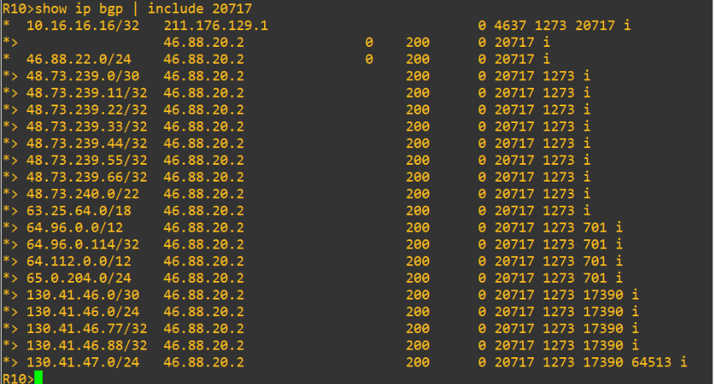

Figure 27 – R10 bgp ips

**3. Discuss other alternative to achieve the same results and comment on their relative pros and cons, compared to your implementation.**

One alternative we could have used is AS-PATH prepending, artificially lengthening the AS-PATH the router advertise to make a route look less preferred to external BGP neighbours.

Pros:

* Very simple to implement.
* Only influences inbound traffic (remote AS will prefer other paths).
* Simple to apply on a per-peer basis.

Cons:

* Not deterministic, remote ASes may ignore long AS paths if they use local-pref, making prepend irrelevant.
* Can require multiple prepends or trial-and-error.
* Scales poorly, if many prefixes need different behaviours, prepend rules become messy.

## PHASE 5 - SECURITY PRACTICES

In this final phase of the project, we focused on BGP security. Our main goal was to secure peering sessions against common threats and implement a mechanism to rapidly block Denial of Service (DoS) attacks at the edge of our network.

To secure the eBGP connection between AS 701 (R14) and AS 1273 (R5), we configured MD5 authentication. Basically, we defined a shared password (BGPpass123) on both routers to ensure that the session is only established between trusted devices. This helps prevent TCP spoofing and session hijacking.

We also verified Bogon filtering on the edge router, R5. Although we had created the prefix-lists in previous steps, in this phase we confirmed that the router is rejecting advertisements of private IPs (such as RFC 1918 ranges) coming from R14 . This is essential to ensure we do not allow "garbage" routes into the global routing table.

Finally, we implemented a Remote Triggered Black Hole (RTBH) mechanism in AS 1273 to mitigate a simulated attack originating from IP 64.96.0.115. We used Router 4 as the "trigger" router to inject a specific /32 route for the attacker's IP. The edge router (R5), which we configured with uRPF and a recursive static route pointing to Null0 , receives this update and automatically starts discarding all traffic from that attacker.

##### Practical Questions

1. How does MD5 authentication improve the security of BGP sessions? What happens if it is not enabled?  
  
MD5 authentication improves security by ensuring that a BGP session can only be established between routers that know the same shared password. In our configuration between R14 and R5, we used the password BGPpass123. This mechanism adds a digital signature to every TCP segment exchanged, which verifies that the peer is legitimate and that the data hasn't been tampered with.

If this feature is not enabled, the BGP session is much more vulnerable. Without the password check, an unauthorized router (or an attacker spoofing the source IP address) could potentially establish a peering session with our routers. This would allow an unauthorized peer to inject false routes into our table, which could lead to traffic hijacking or network instability.

2. Which Bogon ranges did you filter in your lab, and why must they not appear in the global routing table?   
  
In our lab configuration on router R5, we used a prefix-list to explicitly filter out the RFC 1918 private address ranges: 10.0.0.0/8, 172.16.0.0/12, and 192.168.0.0/16 .

These ranges must not appear in the global routing table because they are reserved for private, internal use and are not unique on the public Internet. If these prefixes are advertised globally, it usually means there is a misconfiguration (a route leak) or that someone is trying to spoof source IP addresses for malicious purposes, like hiding their identity during an attack. Keeping these routes out is essential for maintaining "Internet hygiene" and ensures that public routers don't waste resources on non-routable destinations.

3. Explain how RTBH was implemented in AS1273. Include a diagram showing how the trigger router propagates the blackhole route.

We implemented the RTBH (Remote Triggered Black Hole) mechanism by separating the roles between a "trigger" router (R4) and the edge router (R5).

First, on the Trigger Router (R4), we created a static route for the attacker's specific IP (64.96.0.115/32) pointing to Null0 and marked it with tag 66. We then configured BGP to redistribute this static route using a route-map. This route-map rewrites the next-hop attribute to a specific unused IP (192.0.2.1) and attaches the no-export community to ensure the "blackhole" command doesn't leak to other ASes .

On the Edge Router (R5), we configured a static route that sends the unused IP 192.0.2.1 directly to the Null0 interface. When R4 sends the BGP update, R5 installs the route for the attacker's IP with the next-hop 192.0.2.1. Because of recursive routing, R5 sees that 192.0.2.1 goes to Null0, so it immediately drops any traffic associated with the attacker's IP.

4. Describe the role of uRPF in validating traffic source addresses and preventing spoofing.

uRPF (Unicast Reverse Path Forwarding) is a security feature we enabled on the edge router's interface to stop IP spoofing. We configured it using the command ip verify unicast reverse-path on the interface connecting to the external peer.

Its role is to validate the source IP address of every packet that enters the interface. Basically, when a packet arrives, the router looks at its source IP and checks its own routing table to see if it has a valid path back to that IP. If the router determines that the source IP is not reachable (or, in strict mode, if it wouldn't use that same interface to send a response back), it assumes the source address is fake (spoofed) and drops the packet.

In our specific RTBH scenario, uRPF plays a critical role. When we trigger the "black hole" for the attacker's IP (64.96.0.115), the route to that IP is set to Null0. Consequently, when uRPF checks the source IP 64.96.0.115, it sees that the return path points to Null0 (an invalid interface). This causes the validation to fail immediately, and the router drops the malicious traffic right at the edge, preventing it from entering our AS

5. What impact would the attack from 64.96.0.115 have on AS1273 if RTBH was not deployed?

If the RTBH mechanism were not deployed, the malicious traffic generated by the attacker (64.96.0.115) would not be stopped at the network edge. Instead, it would freely enter AS 1273 through the peering link on router R5.

The immediate impact would be the congestion of the peering link, consuming bandwidth that should be available for legitimate users. Furthermore, router R5 and subsequent internal routers would have to waste valuable hardware resources (CPU and memory) processing and forwarding these malicious packets. Ultimately, this flood of traffic would reach its target within our network, likely causing the target service to crash or become unreachable due to the overload, which constitutes a successful Denial of Service (DoS). By using RTBH, we prevent this by dropping the traffic before it can even enter and harm our internal infrastructure.

# Conclusion

In conclusion, this project allowed us to simulate and configure a realistic large-scale network architecture involving multiple Autonomous Systems (ASes), mirroring a real Internet Service Provider (ISP) environment.

We started by establishing the underlying connectivity using OSPF as the IGP, specifically exploring multi-area designs to optimize internal routing. Moving to BGP, we faced the challenges of scalability, which we addressed by implementing Route Reflectors in AS 1273 to avoid the need for a full-mesh iBGP topology.

Beyond basic connectivity, a significant portion of this lab focused on Routing Policies and Traffic Engineering. We successfully manipulated BGP attributes (such as Local Preference and AS-Path) and applied prefix-lists to control exactly which routes are advertised and received, ensuring efficient and symmetric traffic flows.

Finally, the security phase was critical for understanding how to protect the BGP infrastructure. Implementing mechanisms like MD5 authentication, Bogon filtering, and especially Remote Triggered Black Hole (RTBH) gave us practical insight into how network engineers mitigate DoS attacks and secure the network edge. Overall, this lab reinforced our understanding of how BGP acts not just as a routing protocol, but as a powerful tool for policy enforcement and internet stability.

# References

[1] BGP Tools. @ONLINE., November 2025. URL <https://bgp.tools/>

[2] Cisco Systems. @ONLINE., 2025. URL <https://www.cisco.com/>

[3] Cisco Press. Routing TCP/IP Volume II (BGP,MPLS, Advanced IGP). Jeff Doyle, 2nd Edition. @ONLINE., 2005. URL <https://www.ciscopress.com/>

[4] ARIN, @ONLINE 2025, URL <https://www.arin.net/resources/guide/asn/#:~:text=This%20format%20provides%20for%2065%2C536,to%2065534)%20for%20private%20use>.